Branch build

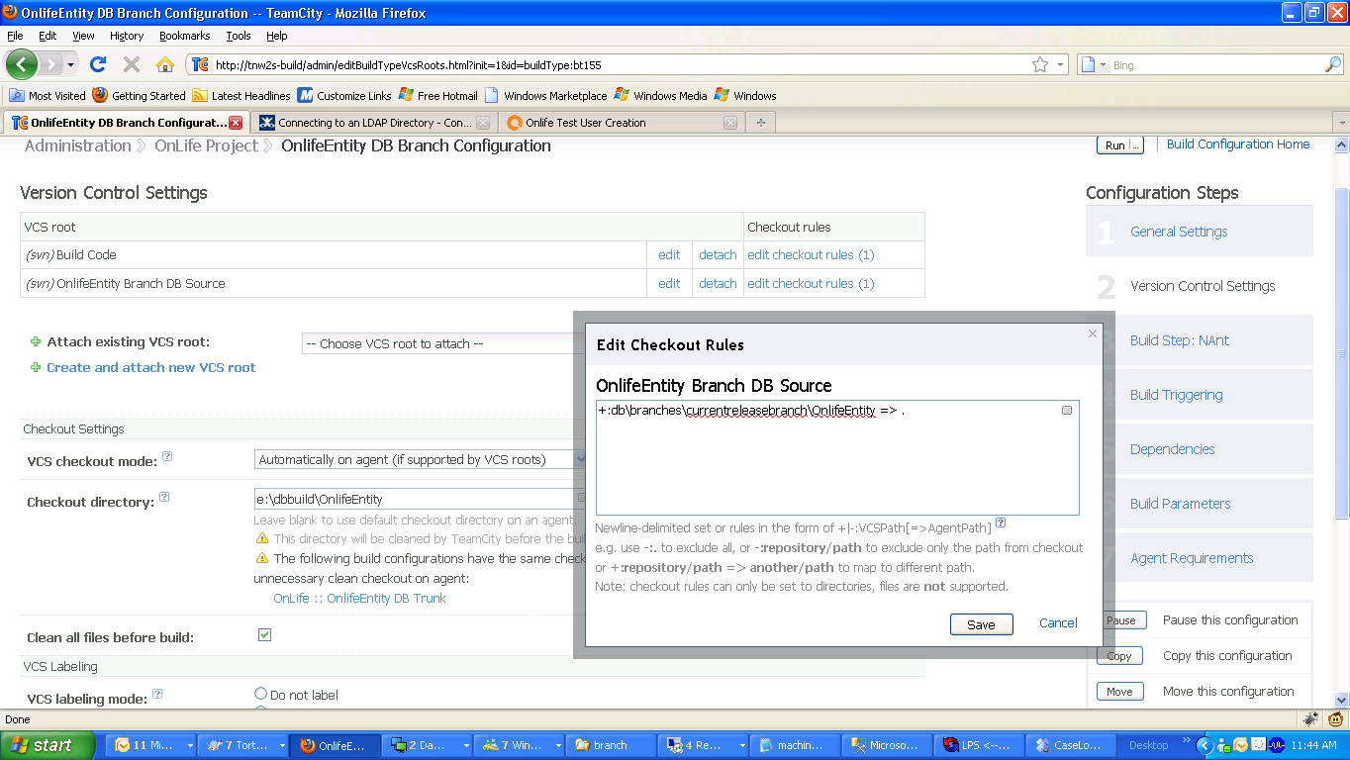

Trunk build

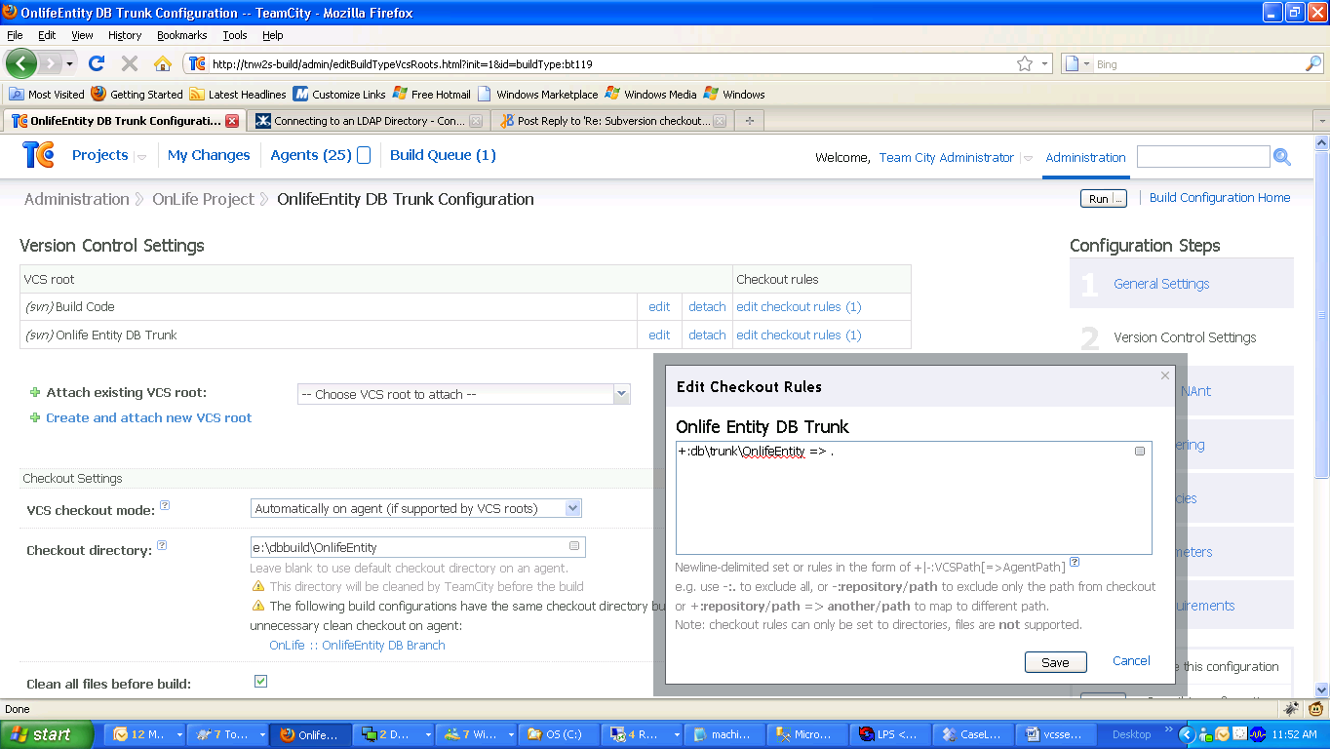

Right after branch build

Source on build machine
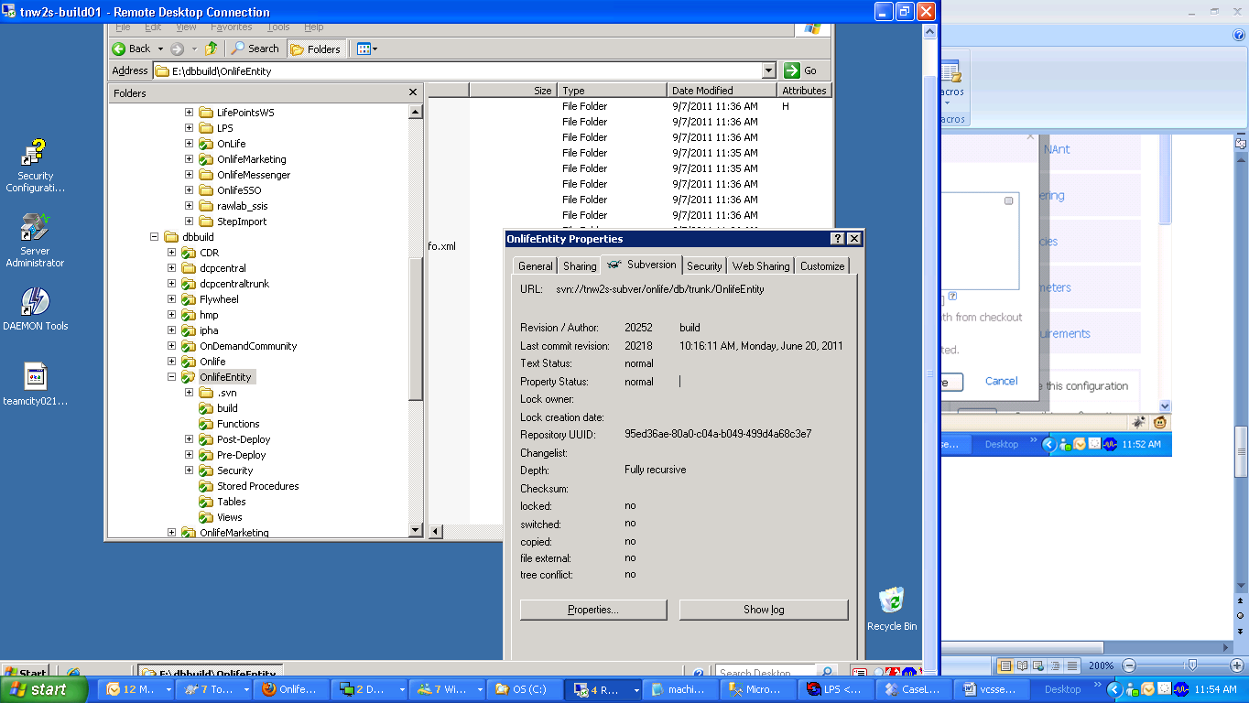
Onlife Entity Branch build showing the same time as on build machine as proof the OnlifeEntity branch build with the source pointing to the branch is bringing down trunk code.

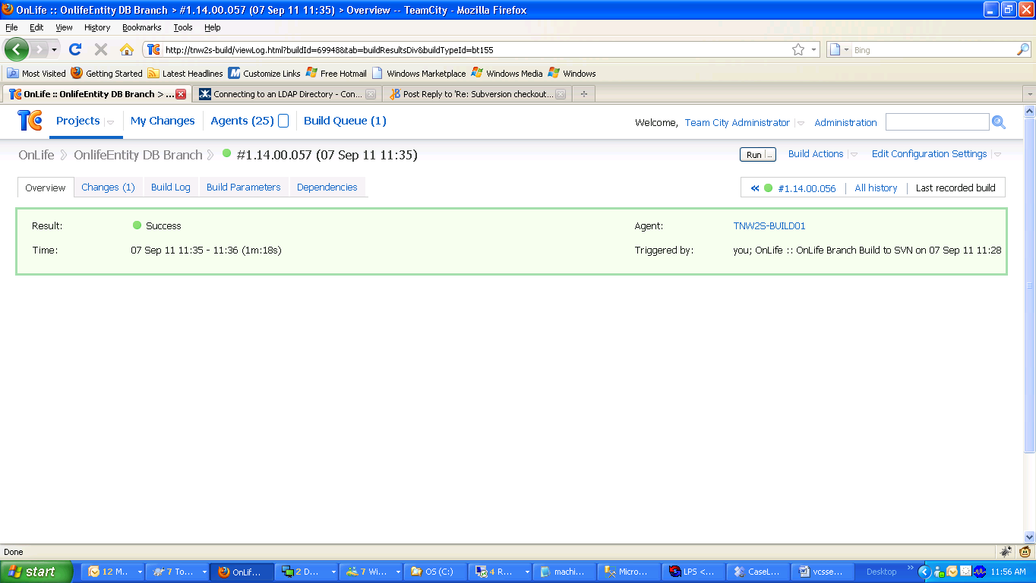
OnlifeEntity trunk build showing yesterday time
